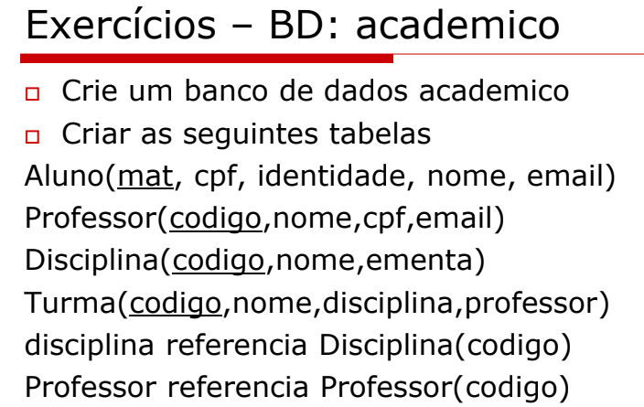

create table aluno(

mat int primary key,

cpf varchar (12) not null,

identidade varchar (12) not null,

nome varchar (50) not null,

email varchar (50) not null

)

create table professor(

codigo int primary key,

nome varchar (50) not null,

cpf varchar (12) not null,

email varchar (50) not null

)

create table disciplina(

codigo int primary key,

nome varchar (50) not null,

ementa varchar (20) not null

)

create table turma(

cod int primary key,

nome varchar (50) not null,

disciplina int not null ,

professor int not null ,

foreign key (disciplina) references disciplina(codigo),

foreign key (professor) references professor(codigo)

)

create table matricula(

coda int,

codt int,

ano int,

semestre int,

nota int,

status varchar(20),

check( semestre = 1 or semestre = 2),

check( status = 'a' or status = 'r' or status = 'c'),

foreign key(coda) references aluno(mat),

foreign key(codt) references turma(cod)

)